Five Maryland-Based Health Systems Come Together to Form
“Advanced Health Collaborative”
March 5, 2015

LifeBridge Health
http://lifebridgehealth.com/Main/PressReleases/495.aspx

Adventist HealthCare
http://www.adventisthealthcare.com/about/news/2015/five-maryland-health-systems-form-advanced-health-collaborative/#.VO3h1vnF91Y

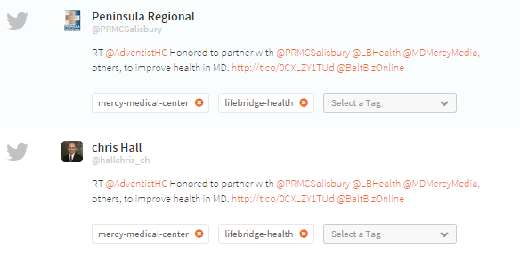

Baltimore Business Journal
http://www.bizjournals.com/baltimore/news/2015/02/24/new-alliance-aims-to-strengthen-marylands.html?page=all

The Baltimore Sun
http://www.baltimoresun.com/health/blog/bs-hs-hospital-alliance-20150224-story.html
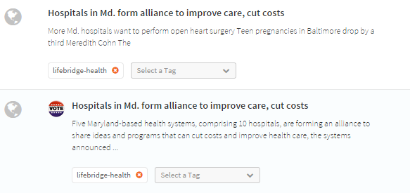

Baltimore City and Press
http://baltimore.cityandpress.com/node/9185172

Modern Healthcare
http://www.modernhealthcare.com/article/20150224/NEWS/150229961/maryland-systems-collaborate-on-population-health

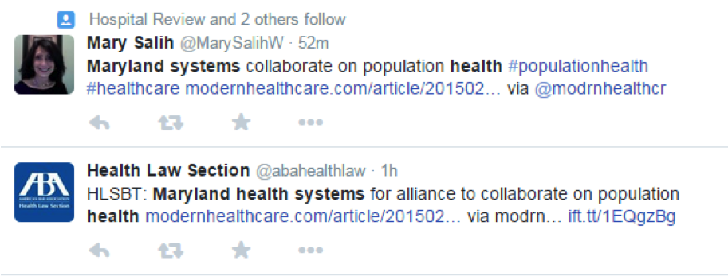

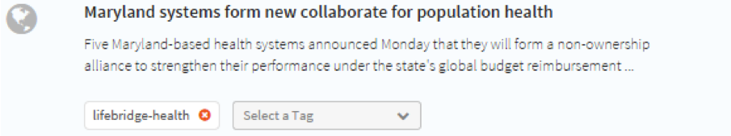

The Frederick News Post
http://www.fredericknewspost.com/news/health/insurance/frederick-memorial-regional-hospitals-enter-into-multigroup-collaborative/article_15f77fa1-d58e-568d-9d0e-24d394b5ebd3.html
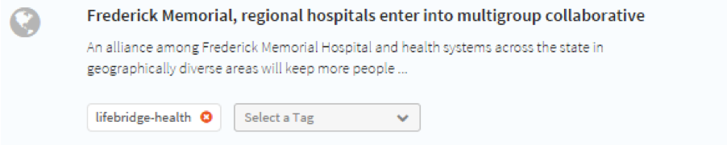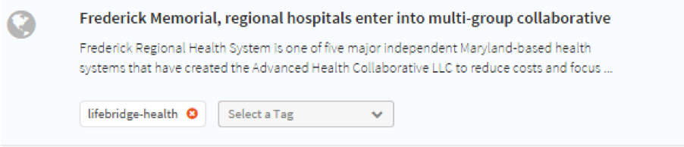

Peninsula Regional
http://www.peninsula.org/body.cfm?id=35&action=detail&ref=1131

Advance Healthcare Network
http://nursing.advanceweb.com/News/National-News/Five-Maryland-Based-Health-Systems-Come-Together-to-Form-Advanced-Health-Collaborative.aspx
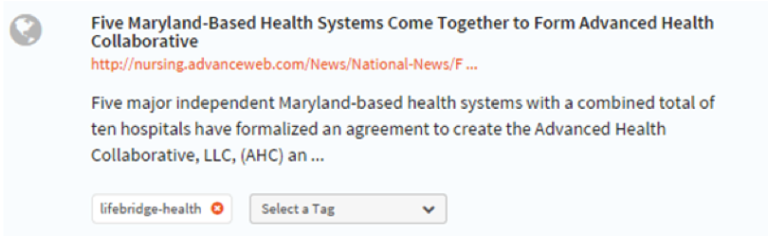

Carroll County Times
http://www.carrollcountytimes.com/news/business_technology/bs-hs-hospital-alliance-20150224,0,832487.story

Mercy Baltimore MD
https://mdmercy.com/news-and-events/media-relations/news-by-mercy/2015/february/mercy-joins-advanced-health-collaborative
Health IT Analytics
http://healthitanalytics.com/2015/02/27/md-health-systems-collaborate-for-population-health-management/

The Advisory Board Company
http://www.advisory.com/daily-briefing/2015/02/26/aco-roundup
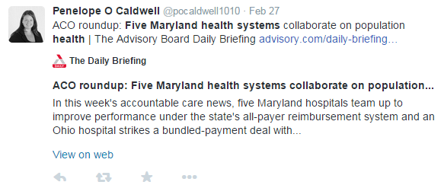
The Max
http://www.uslifeline.com/News.aspx

Fierce Healthcare
http://www.fiercehealthcare.com/story/hospitals-go-big-take-population-health-management/2015-02-25

Healthcare Finance
http://www.healthcarefinancenews.com/news/maryland-hospitals-form-network-leverage-state-reimbursement

The Ronan Report
http://theronanreport.blogspot.com/2015/02/advanced-health-collaborative.html

The Becker Hospital Review
http://www.beckershospitalreview.com/population-health/5-health-systems-form-alliance-in-maryland.html

