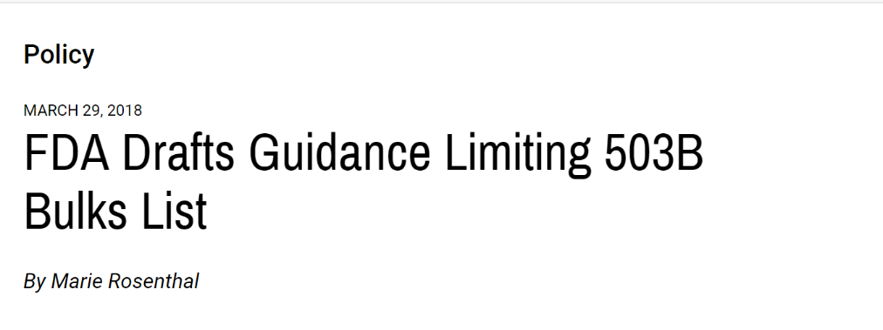
The FDA released a draft guidance document that will limit the bulk drug substances that 503B facilities can use in compounding, giving preference to the use of branded products over compounding from bulk components.
As part of the implementation of the Drug Quality and Security Act (DQSA), approved in 2013, the FDA was directed to develop a list of bulk drug substances “for which there is a clinical need.” The new guidance attempts to address that requirement, according to FDA Commissioner Scott Gottlieb, MD.
“We’re issuing a critical policy document that addresses how that list will be formulated, and what bulk drug substances the outsourcing facilities can use to compound drugs,” he wrote, adding that this list is part of a comprehensive policy framework for DQSA.
The “Evaluation of Bulk Drug Substances Nominated for Use in Compounding Under Section 503B of the Federal Food, Drug, and Cosmetic Act,” discusses the FDA’s interpretation of the statutory phrase “bulk drug substances for which there is a clinical need,” as well as criteria the agency proposes to use when evaluating whether to include a bulk drug substance in the list of bulk drug substances that may be used in compounding drugs.
“The FDA continues to elevate the quality standards and GMPs of compounding under 503B of the Federal Food, Drug, and Cosmetic Act. The quality of drug product has certainly been improved as a consequence, whether the source starting material is sterile drug product or bulk powder,” said Stuart Hinchen, CEO of QuVa Pharma.
Mr. Hinchen added that the FDA’s recent guidance Evaluation of Bulk Drug Substances is consistent with its previous statements, and also reported statements of pharmaceutical drug companies that have been applying pressure to the FDA for change in 503B compounding. However, the outcome of applying the guidance could be an exacerbation of the drug shortages facing hospital systems and patients; fewer 503B participants at a regional level; restricted access to innovative ready-to-use preparations with improved stability dating; and higher pharmaceutical costs to health care providers, he explained.
“Access to bulk drug product as starting material is essential to facilitate innovative formulations that can achieve extended shelf lives for ready-to-use product. In turn, extended shelf lives facilitates USP-based testing of compounded preparations not otherwise available using commercially sourced product. Reducing potential for medication errors in the hospital setting results in improved patient outcomes,” Mr. Hinchen said.
“We are still evaluating the full potential impact of the new draft guidance. However, in the absence of a clearly defined clinical need, CAPS [Central Admixture Pharmacy Services Inc.] supports prohibiting the use of bulk drug substances when an FDA-approved drug product is otherwise available,” said Mike Koch, the senior vice president of CAPS., which is part of the B. Braun group of companies.
The FDA is proposing to interpret the statutory language, “bulk drug substances for which there is a clinical need,” to mean there is a clinical reason for an outsourcing facility to compound a drug product using a bulk drug substance instead of the branded product as a starting point.
“In many cases, a bulk drug substance is a component of an FDA-approved drug product. In assessing the clinical need for a drug to be compounded from bulk substance in these circumstances, the first step of the FDA’s analysis involves the agency considering whether attributes of the approved drug may make it unsuitable to treat certain patients for particular conditions—and whether the compounded drug is intended to address that attribute. The FDA also intends to consider whether the drug product to be compounded must be produced from a bulk drug substance rather than an approved drug,” Dr. Gottlieb said in his statement.
For example, if an approved drug contains peanut oil, the FDA would consider whether there was information indicating that patients with a peanut allergy need to take a product without the allergen and whether the drug product needed to be compounded using a bulk drug substance rather than the approved drug, because the type and number of manipulations necessary to remove the peanut oil from the approved product would adversely affect the overall quality of the drug.
A second step of the clinical need analysis would be whether the bulk drug substances are components of FDA-approved drugs and would weigh certain factors for each substance, specifically its physical and chemical characterization, safety issues, efficacy and historical use.
“Compounding can be critical for advancing the health of patients who have specific medical needs that cannot be met by FDA-approved drugs. However, because compounded drugs are not FDA approved and do not undergo premarket review by the FDA for safety, effectiveness and quality, they also present a greater risk to patients than FDA-approved drugs,” Dr. Gottlieb said.
The new guidance will limit the number of products that can be made from bulk components.
“Given the need for high quality control and patient safety, the recently passed Omnibus Bill (H.R. 1625) instructs the FDA to prohibit outsourcing facilities from compounding drug products from bulk ingredients when outsourcing facilities could otherwise be compounding from an FDA-approved drug product,” said Jenn Adams, the senior vice president and president of Clinical Product Solutions, at PharMEDium, which employs a “sterile-to-sterile” compounding process.
“Specifically, this process ensures that our products are only compounded from sterile finished dosage–form drugs from pharmaceutical manufacturers who have obtained an NDA or ANDA approval from the FDA,” Ms. Adams said. “PharMEDium believes that this approach to compounding is safer than compounding using bulk drug substances for a variety of reasons, though one of the most significant is the fact that our process requires fewer aseptic manipulations than that of a traditional drug manufacturer who produces sterile drugs through aseptic processing or a 503B outsourcing facility that compounds drugs from nonsterile bulk drug substance powders.”

