**Six Tips for Boosting Lead Generation Via Social Media Marketing**

*Summary/Excerpt: Improving landing page quality, audience targeting and content creation results in greater ROI when using social media marketing for lead generation. Read our new blog post to find tips for your next campaign.*

Acquiring new customers can be a difficult yet crucial process for virtually all businesses. Especially for B2B marketing, generating quality leads helps businesses turn prospects into customers, but Hubspot research found that [63% of businesses find lead generation to be their biggest marketing challenge.](https://www.hubspot.com/marketing-statistics) Initiating this process involves raising awareness for your businesses among qualified audiences. Fortunately, 21% of marketers believe [social media has a significant impact on meeting lead generation goals.](https://www.salesmate.io/blog/lead-generation-statistics/) In this blog, we’ll look at six tips for using social media effectively in your lead generation efforts.

**Start with a Quality Landing Page**

Even with top-notch content and targeting strategies, your efforts can be wasted if the landing page doesn’t function properly. The goal is to make things easy as possible for your potential leads.

Most marketers prioritize generating high-quality leads.  
Source: [Salesmate](https://www.salesmate.io/blog/lead-generation-statistics/)

For the form itself, make sure it’s easily visible near the top of the page. While it doesn’t have to be the first thing people see upon loading the page, keeping it “above the fold” means they won’t have to scroll down to find it. The forms should also be short but useful. The idea is to avoid scaring would-be leads away with too many fields, while also ensuring that you get all the vital details from those who do fill them out.

Page load times are also crucial for generating leads. A landing page that is too slow to load risks losing the interest of more impatient potential leads. Seconds can mean the difference between driving conversions successfully and causing visitors to “bounce” from the page.

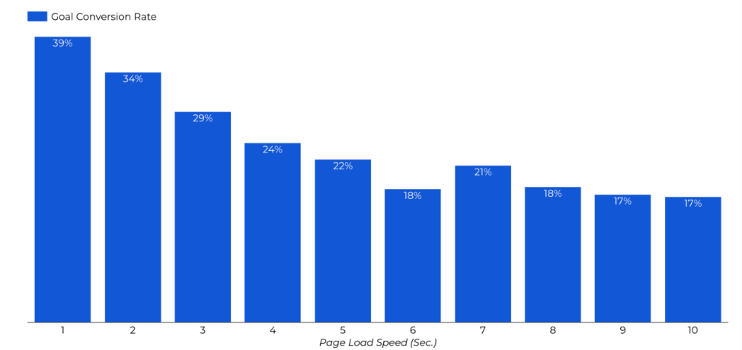

Slower page load speeds are associated with lower conversion rates.   
Source: [Portent](https://www.portent.com/blog/analytics/research-site-speed-hurting-everyones-revenue.htm)

**Target the Right Audience**

Regardless of the objective, audience targeting is a crucial aspect of any social media marketing campaign. With the sheer volume of people using various social media platforms on a daily basis, sponsored content is basically a no-brainer if you’re trying to reach people outside your scope of followers.

Paid campaigns allow you to target people based on interests, location, and other demographic factors. When it comes to B2B marketing, targeting by job experience is especially important. If you know a piece of content or a product or service would be appealing to people in certain positions or with specific companies, you can build a target audience that includes only those people. This increases the chance the people will click and open your ads and fill out forms to convert to leads.

When using these target audiences, track how certain parameters perform to determine how impactful and valuable they are when included. If you notice that specific job titles aren’t yielding strong performance, removing them can help avoid wasted budget dollars.

**Include a Clear Call-to-Action**

3E PR Client FUJINON Lenses utilizes CTA buttons in Facebook ads to drive event registrations.

Social media often calls for clear and concise language to catch users’ attention and convey the necessary information quickly. And when the specific goal is lead generation, a clear call-to-action (CTA) should be included to make clear what specific task you’d like your audience to perform.

While including short CTAs like “download” or “subscribe” can be effective, being more specific with the wording can be more appealing. Pairing those action words with more conversational language can help create a more personal tone while still encouraging your audience to take action. Using “Download your free eBook” or “Subscribe to our newsletter,” maintains that positive and conversational tone while also describing exactly what users will get in return for providing their information.

When creating social media ads, you’ll often have the option to add specific CTA buttons with prewritten language variations. While the language is short, and the options can be limited, these buttons have been associated with a [83% increase in conversion rates](https://www.socialpilot.co/blog/social-media-call-to-action) when utilized.

**Create Quality Imagery**

Building successful lead-generating social media content lies in creating posts and ads that effectively engage your audience. In a previous blog, I explained how [quality imagery is paramount for driving engagement.](https://www.3epr.com/maximizing-social-media-engagement-with-content/) The case is no different for driving leads. If you want people to interact with your ads, you’ll need to catch their attention and persuade them to provide their information.

Even if a webinar, eBook, white paper or newsletter is valuable to a prospect, you need to clearly show them the value if you want them to convert. Images offer an opportunity to get this point across in your social media ads, as they can be pried with strong copy to demonstrate exactly why they need to download your materials or subscribe to your mailing list.

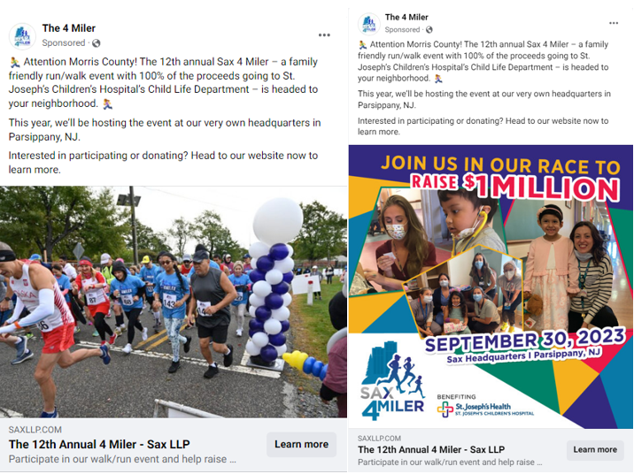

3E PR client Sax LLP utilizes multiple forms of imagery to promote a charity run raising money for St. Joseph’s Children’s Hospital.

When possible, including visuals featuring the products or services being offered can help your audience form a connection with what you’re promoting. Branded imagery also helps build awareness and recognition, giving users to the opportunity to become more familiar with your business.

Imagery in social media ads can also complement the copy with eye-catching details or statistics and help your content stand out. Copy should be kept clear and concise, to ensure all the necessary information can be obtained quickly.

If you’re promoting an event, the image can include the time and location details so that they don’t need to be in the copy. For eBooks and other similar materials, the titles should be shown to help easily convey what the piece of content is about.

**Make Use of Off-platform Analytics Tools**

Your interest in a prospect doesn’t end once they click your social media ads, so why should your analytical capabilities end there? Fortunately, there are useful tools that allow marketers to track activity on their own websites after they’ve driven traffic from social media ads.

Through use of Meta Pixels, LinkedIn Insight Tags and Google Analytics, you can truly assess how successful your social media marketing strategy has been at generating leads. In a simple form, using Google Analytics data to see how much time visitors spend on specific webpages when coming from your ads can help determine if you’re targeting the right audience. If the metrics report that visitors from LinkedIn ads are dropping off immediately without visiting any other pages, it could suggest that the audience being reached isn’t interested enough in your content. If so, your targeting strategy needs work. Read our recent blog post to learn more about [audience targeting strategies.](https://www.3epr.com/audience-targeting/)

Achieving the full benefits of these tools also lies in using them to retarget people and create lookalike audiences. With Meta Pixels and LinkedIn Insight Tags, you can build audiences comprised of people who visited the landing page, allowing you to continue reaching people who have already demonstrated interest by visiting the website. You can also use this data to build lookalike audiences, including people whose activity resembles those who have interacted with your content, further widening your social media advertising campaigns’ reach.

Using these tools also enables marketers to create ads with conversion-focused objectives. Rather than just relying on social media platforms to reach people likely to click on links, these ads prioritize those who are more likely to convert. Plus, using this targeting strategy also allows you to see exactly how many people converted as a direct result of your ads, helping you better assess ROI.

**Create Form Fill Ads**

The traditional approach to using social media for lead generation involves driving an audience to landing pages, where they can fill out forms to access content. However, specific ads can be created that cut out a step and let people convert on the social media platform. This adds a level of convenience to the targeted audience that can increase the chance of conversions. The leads can be exported into a file or you [can integrate your preferred CRM software](https://www.facebook.com/business/help/908902042493104?id=735435806665862), so you won’t miss a beat in your overall marketing strategy.

While keeping the audience on platform can be beneficial in driving more leads, it may not be an ideal objective if you also value the website traffic associated with a traditional lead-generating landing page. Maintaining a steady stream of visitors to your website can be especially valuable if there are other useful materials and resources that could also aid lead-gen efforts. If this is the case, that traffic should be prioritized.

When executed properly, social media marketing can be an incredible lead generation tool. A major aspect of social media’s increasing value as an advertising platform lies in the fact that it’s constantly attracting more users. After all, it media recently overtook paid search as an advertising channel, [growing 25% year over year and exceeding $137 billion](https://www.zenithmedia.com/ecommerce-and-online-video-to-fuel-11-recovery-in-global-adspend-this-year/). And as you optimize social media campaigns and their performance improves, the data collected can be used to fuel even more success, making it “the gift that keeps on giving.”

If you’re interested in learning more about using social media to generate more leads, [email me now](mailto:mcalia@3epr.com).